**School Healthy Break Policy**

Belle Vue school recognises the importance of a healthy balanced diet for its pupils and staff and acknowledges the daily consumption of a mid morning snack will have a significant impact on a child’s dietary intake. Therefore Belle Vue School will adopt Dudley Healthy School’s recommended Healthy Break Policy.

**Food / drink brought in from home:**

Pupils and parents will be encouraged to only bring from home the following food and drink items for their break-time snack:

üWater

ü Fruit

ü Vegetables

**Pupils with special diets:**

The foods and drinks recommended for the Healthy Breaks Policy will be suitable for most therapeutic diets. However any pupil following a specific diet devised by a dietician must adhere to it. If any issues arise staff will consult parents/carers or relevant health professionals for advice.

**Communication:**

The policy will be communicated with staff, Governors, parents/carers and pupils in the following ways: üStaff will be informed through a staff meeting

ü Governors will be asked to agree and adopt policy at Governors meeting ü Pupils will be informed through a classroom discussion or an assembly ü Parents/ carers will be informed through a letter and the school website

**Monitoring:**

Staff will be responsible for monitoring and implementing the policy.

**Review:**

The policy will be reviewed every 2 years.

**Healthy eating ethos of the school:**

The Healthy Break Policy is part of a wider Whole School Food Policy which sets out a coordinated approach to all aspects of food within school.

Signed (Head Teacher):

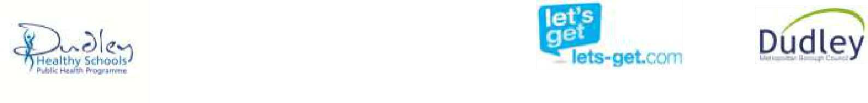Review Date: September 2026